LAB 8

EXERCISE 2

QUESTION 2

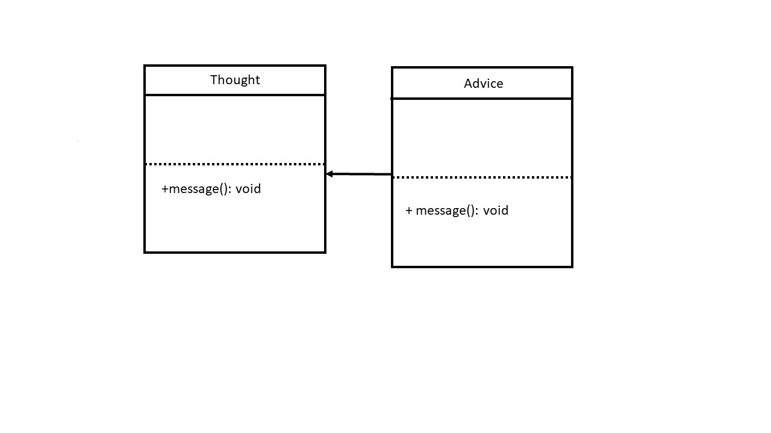

The objects of Thought and Advice are created and then the following statements has call the function message of these two objects respectively. Therefore, it prints out the statement in the two different functions respectively.

The objects of Thought and Advice are created just like the previous one. However, the function message of Advice has a statement which called the function message of Thought class. Therefore, the output will print out the statement of message of class Thought twice and then the statement of the message of Advice class.